**Data source**

This dataset was gotten from Kaggle’s website: <https://www.kaggle.com/datasets/russellyates88/suicide-rates-overview-1985-to-2016>.

**Data Cleaning**

I made the following transformations on the raw dataset:

* Removed the gridlines and formatted the headers
* Center aligned the all the data
* Formatted the date to the correct date format

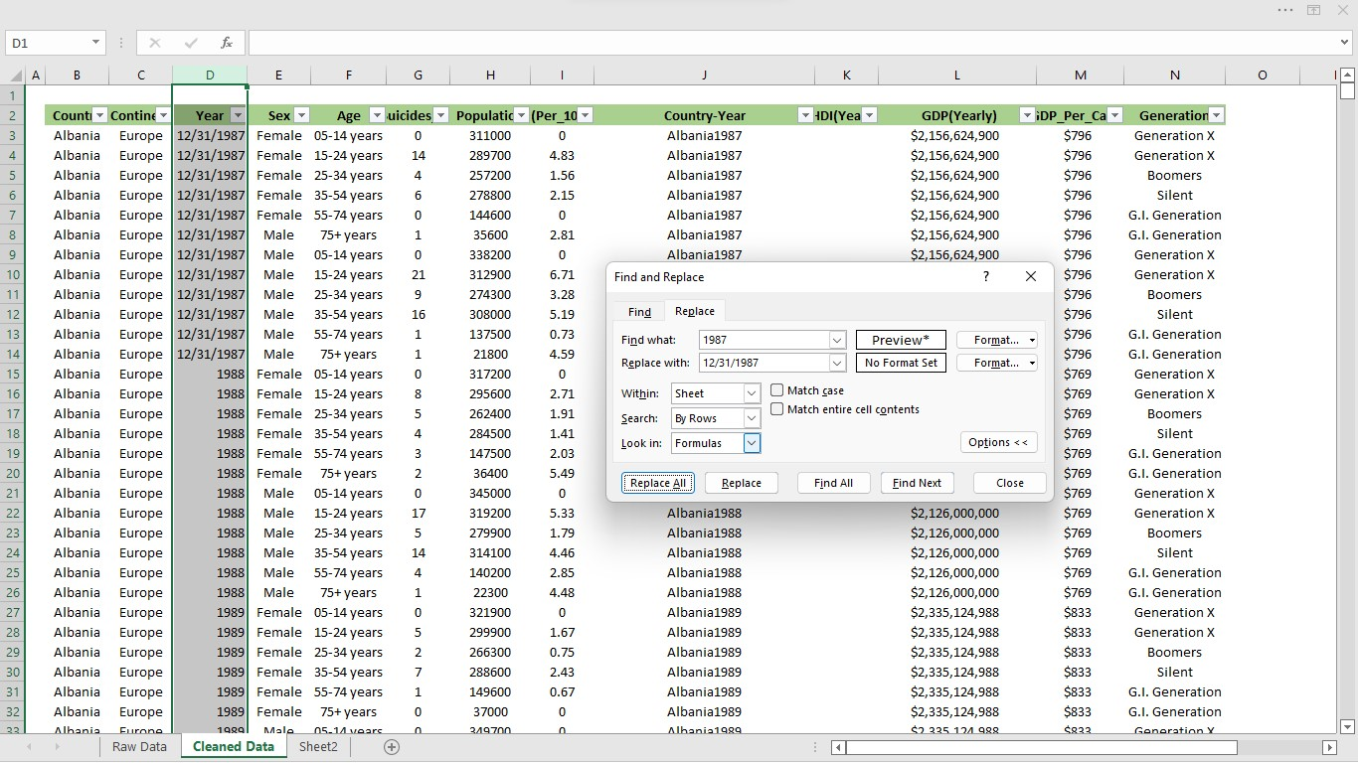

I then imported the data on Microsoft Power BI. There I removed the “year” value from the age.

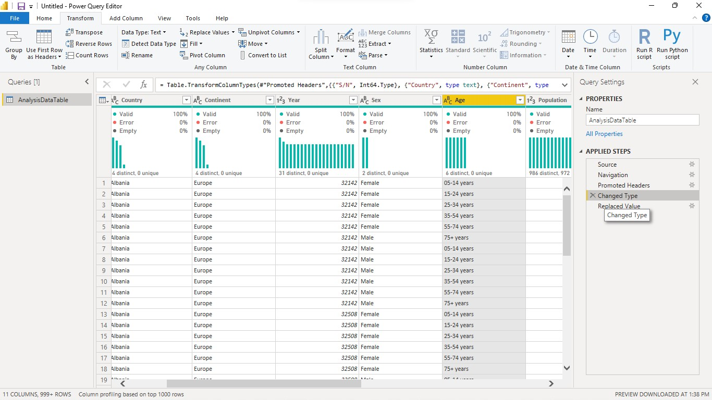

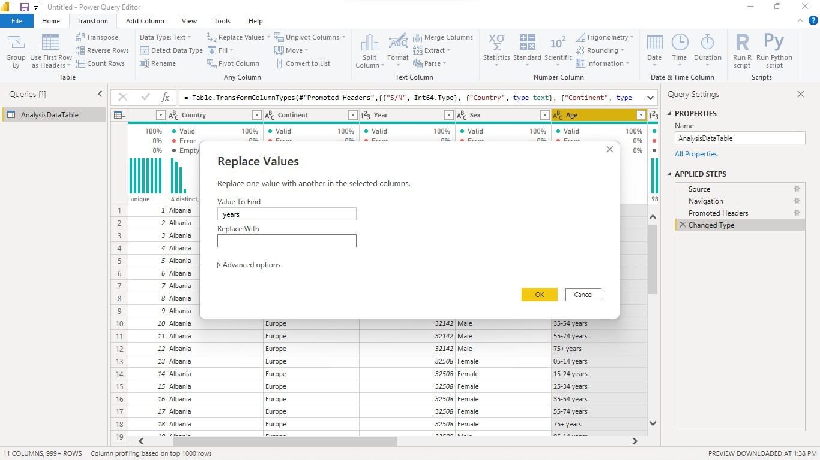

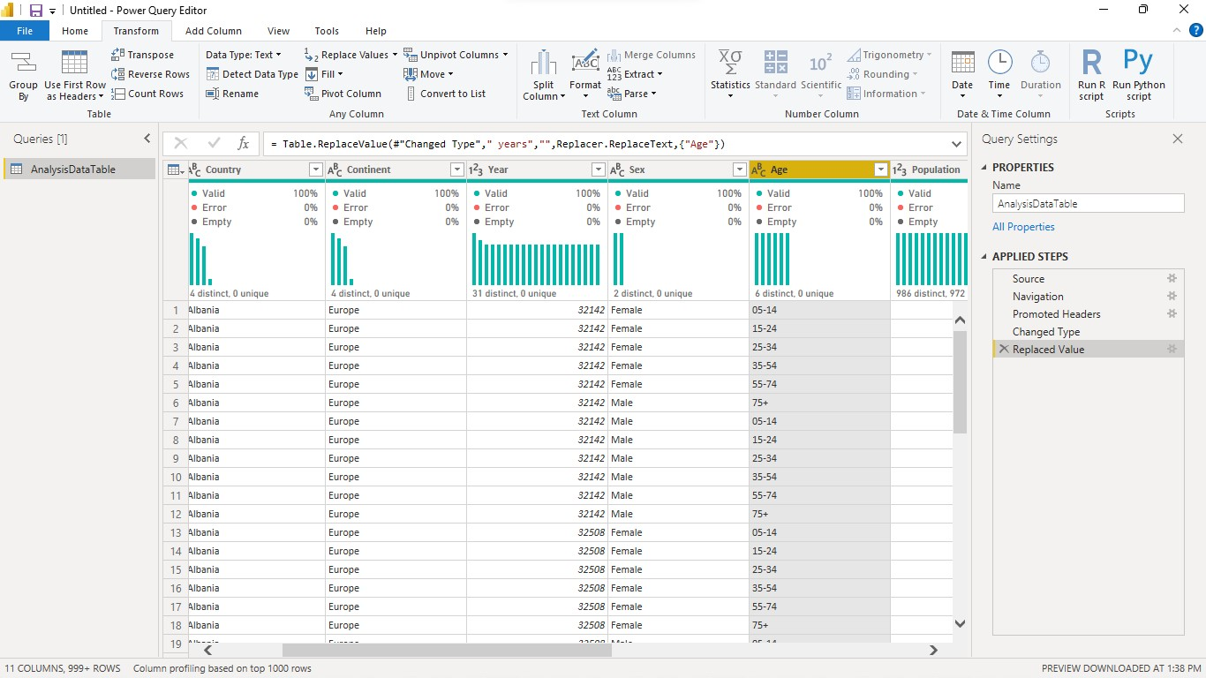

Then, using the guide questions below, I analyzed the data and came up with the dashboard.

**Descriptive Analysis**

* Which continent or country has more or less suicide cases than the other?
* What year did we record the highest or lowest suicide rate?
* The spread of male vs female suicide cases
* What’s the age spread of suicide cases

**Diagnostic Analysis**

* What’s the suicide per population count each year?
* What’s the correlation between the standard of living and the suicide rates?
* As the Gdp_per_year fluctuates over the years, has the suicide no also fluctuated?

**Dashboard**

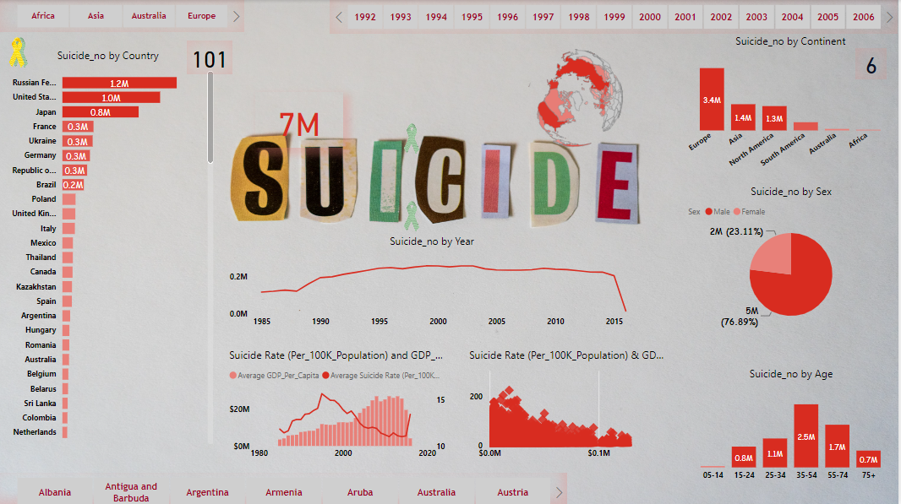  
﻿

**Insight**

* Average GDP_Per_Capita (17.04% increase) and Average Suicide Rate (Per_100K_Population) (13.49% increase) both trended up between 1985 and 2016.﻿﻿ ﻿﻿
* Average Suicide Rate (Per_100K_Population) started trending down on 2005, falling by 8.07% (0.97) in 10 years.﻿﻿ ﻿Suicide no dropped from 230,160 to 15,603 during its steepest decline between 2012 and 2016.﻿﻿ ﻿﻿﻿﻿
* Suicide no was unexpectedly low on 2016. It had a value of 15,603, which is outside the expected range of 127,969-254,290.﻿﻿ ﻿﻿ ﻿﻿
* The most recent anomaly was in 2016, when Suicide no had a low value of 15,603.﻿﻿ ﻿﻿Russian Federation accounted for 17.93% of Suicide no.﻿﻿ ﻿﻿ ﻿﻿
* Across all 6 Continent, Suicide no ranged from 11, 355 to 3,423,870.
* Russia has had the highest no of suicide cases.
* The United States and Russia have consistently recorded the highest no of suicides per year.
* Europe has the highest record of suicide cases.
* On an average, Russia, United States, Japan, Republic of Korea, Ukraine and Germany lead the chart consistently through out all the years.
* More males have been victims of rape than females with a total number of 5,188,911 deaths.
* Africa with a record of 11,355 deaths, has had the lowest amounts of deaths from suicide.
* People aged 35-54 had the highest suicide death no 2,452,141, and as expected, those from the ages 5-14 had the least, 52,264.
* On an average, there’s been a negative correlation between the standard of living and suicide rates.